Individual Final Project

Industrial Revolution: A.I. and Automation

BAIS:6140 Information Visualization

Prepared By: Michael Lee

I. Executive Summary

Artificial intelligence has already led to increased quality of life, to some extent. Computer systems have created a boon for the service industry, leading to efficiency and more free time for individuals. Booking a flight, ordering food, making a payment, or watching a movie can all be done remotely, and within seconds. As we are entering the Fourth Industrial Revolution; the combination of artificial intelligence and automated machines. This technological advancement has the ability to transform the world. It will affect human labor, ethics, governments, and quality of life. This revolution has the capacity to be constructive or destructive; it remains inconclusive.

II. US Job Market, Wage Distribution, & Occupational Salary Statistics

Every industrial revolution has created disruption. Disruption does not necessarily mean net-elimination; intelligent and automated machines will eliminate jobs and possibly entire industries, but it has also been proven that these machines will lead to jobs and industries being created. Figure 1 provides the brief overview of the current US job market.

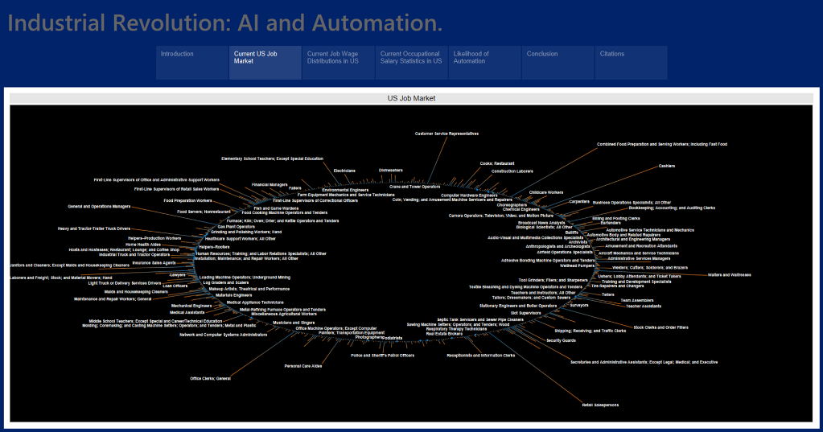

Figure 1. US Job Market

States will need to fight with the potential labor disruption. According to the article “ The Future Of Employment: How Susceptible Are Jobs To Computerization? “, authors estimate about 47 percent of total US employment is at risk. Governments will have to enact legislation that protects its citizens from this unemployment. While this revolution will affect virtually every aspect of modern life, adopting and changing policies can aid countries towards a smooth transition. Figure 2 & Figure 3 highlighted uneven wage distribution and occupational salary statistics in the current US labor market, and how to improve the current situation and keeping the fairness among the revolution would be something Governments have to take it into account.

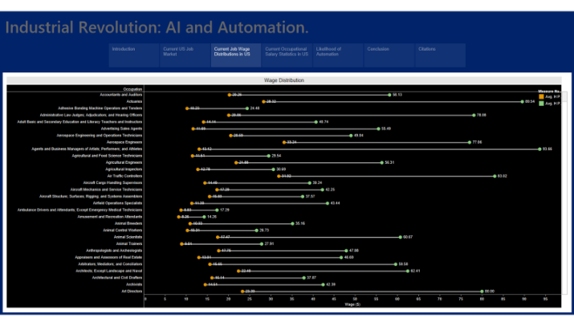

Figure 2. Wage Distribution in US

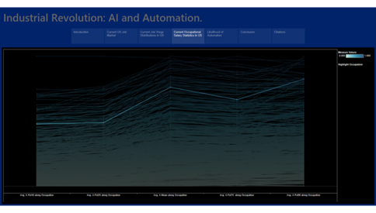

Figure 3. Occupational Salary Statistics in US

III. Occupational Likelihood of Automation

Base of the article “The Future Of Employment: How Susceptible Are Jobs To Computerization?” by Carl Benedikt Frey and Michael A. Osborne, they are able to estimate the probability of computerization for over 702 different occupations, using a Gaussian process classifier, and further examine expected impacts of future computerization in US labor market with primary objective of analyzing the number of jobs at risk and the relationship between an occupation’s probability of computerization as *Figure 4* shown based on these estimates.

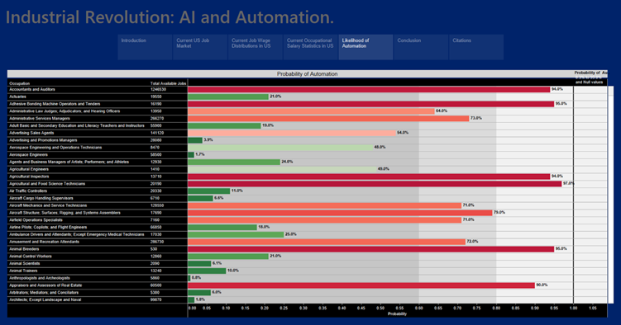

Figure 4. Likelihood Of Automation

IV. Summary, Conclusions & Recommendations

The most important lesson to learn from the Fourth Industrial Revolution is that artificial intelligence – more broadly technology – is widely uncertain. It cannot be stressed enough that it is up citizens to urge their lawmakers to enact policies that promote healthier democracies. This will engender a safer world with a better quality of life – courtesy of artificial intelligence.

Technology has always been a driving force behind exponential growth and development to create human progress. As Stephen Hawking mentioned before, “Intelligence is the ability to adapt to change”.

References

* <https://www.washingtonpost.com/news/answer-sheet/wp/2018/03/29/stephen-hawking-famously-said-intelligence-is-the-ability-to-adapt-to-change-but-did-he-really-say-it/>
* Salary Data

[@misc](https://www.kaggle.com/misc){u.s. bureau of labor statistics,  
title={Occupational Employment Statistics},  
url={[https://www.bls.gov/oes/current/oes_nat.htm}](https://www.bls.gov/oes/current/oes_nat.htm%7D),  
journal={U.S. BUREAU OF LABOR STATISTICS}}

* Automation Data

[@article](https://www.kaggle.com/article){frey*osborne*2017,  
title={The future of employment: How susceptible are jobs to computerisation?},  
volume={114},  
DOI={10.1016/j.techfore.2016.08.019},  
journal={Technological Forecasting and Social Change},  
author={Frey, Carl Benedikt and Osborne, Michael A.},  
year={2017},  
pages={254–280}}